Name: Dr. Suraksha Chanotra
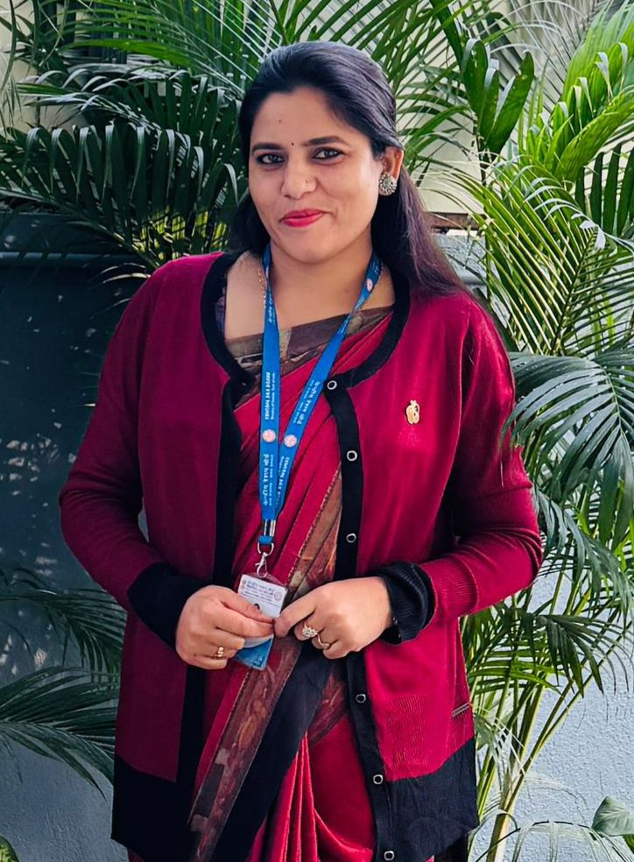

Scientist-B & Incharge: CSB, MESSO, P3 Unit, Kowabil, Kokrajhar-Assam-783370.
Contact no.: +91-7780986497
e-mail: drsuraksha.csb@nic.in
chanotrasuraksha@gmail.com

Dr. Suraksha Chanotra is presently working as Scientist-B in Central Silk Board, Ministry of Textile, Govt. of India. She is currently posted at CSB, MESSO, P3 Unit, Kowabil, Kokrajhar-Assam. She did her Doctorate degree from Sher-e-Kashmir University of Agricultural Sciences and Technology of Jammu. She has more than 40 original research papers in reputed/referred national and international journals of India and overseas. She received a merit certificate for her outstanding performance in M.Sc., University Merit Scholarship, and RGNF National Fellowship by Govt. of India. She has a number of awards to her honor like Young Scientist Award, Best Thesis Award, Excellent Researcher Award, Best Sericulturist Award, Outstanding Academician Award, Global Women Scientist Award, Outstanding Achievement Award etc. from time to time for her continuous efforts and interest in the field of sericulture. She has also published 07 books and many book chapters. She also writes newspaper articles regularly for reputed papers like Daily Excelsior and Greater Kashmir etc. She has also presented her research works in more than 24 National and 11 international conferences and has attended many seminars/conferences/workshops/ webinars from time to time. She has also participated in various training programmes and workshops organized by different Govt./Semi-Govt./NGOS & Scientific Agencies. Her areas of research expertise are mulberry plant biotechnology and DNA Fingerprinting.
Job Profile: Working as Scientist-B in Central silk Board, Ministry of Textile, Govt. of India.
Designation: Scientist-B & Incharge, CSB, MESSO, P3 Unit, Kowabil, Kokrajhar-Assam.
Year of Entry to the Board: November 2023
Current Posting: Central Silk Borad, Muga Eri Silkworm Seed Organization, P3 Unit, Kowabil, Kokrajhar-Assam.
Job Description: Administrative Work and Supervision of grainage production and lab testing for assuring supply of healthy and disease free layings.
Publications: 40 Research publications in journals of country and overseas and 7 books and 12 book chapters.
Membership: Life Member of NASSI Banglore, SIDAVES, RASSA and ATEDS.

